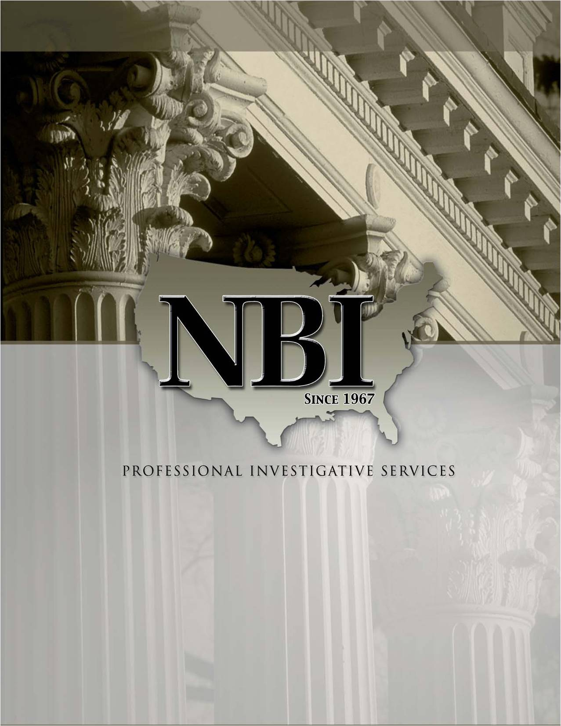

**NBI SERVICES**

Surveillance

Locates & Skips

Insurance Defense

Assets Searches

Litigation Support

Corporate Theft

Civil/Criminal Records Research

Business / Corporations

Background Investigations & Screening

Thank you again for your interest in NBI, Inc. Please feel free to call us if you have any further questions at 866.624.8050.